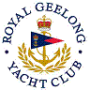 | Royal Geelong Yacht Club Inc.  Est 1859
Trophy Deed of Gift.

Trophy: | Race Committee Perpetual Cup
Presented by:
Date: | 2007
For: | Yacht Competing in the most Club Events for the Season
Remarks / Revisions
Click HERE for a list of the Recipients

